Description for Task 1: Sales Performance

Get the dataset (xls file) [here.](https://drive.google.com/drive/folders/1xql56CMrIKNppRjQOF61wNKTPmTMr46z?usp=sharing)

Description:

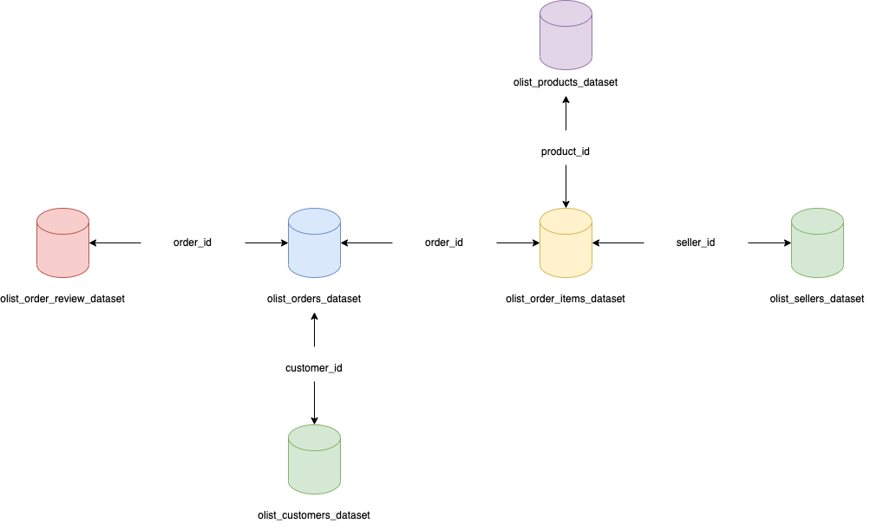

olist_orders_dataset

| order_id | Unique identifier of the order. |
| --- | --- |
| customer_id | Key to the customer dataset. Each order has a unique customer_id. |
| order_status | Reference to the order status (delivered, shipped, etc). |
| order_purchase_time | Shows the purchase timestamp. |
| order_approved_at | Shows the payment approval timestamp. |
| order_delivered_carrier_data | Shows the order posting timestamp. When it was handled to the logistic partner. |
| order_delivered_customer_date | Shows the actual order delivery date to the customer.  calendar_today |
| order_estimated_delivered_date | Shows the estimated delivery date that was informed to customer at the purchase moment. |

olist_customers_dataset

| customer_id | key to the orders dataset. Each order has a unique customer_id. |
| --- | --- |
| customer_unique_id | unique identifier of a customer. |
| customer_zip_code | first five digits of customer zip code |
| customer_city | customer city name |
| customer_state | Customer state name |

olist_sellers_dataset

| seller_id | seller unique identifier |
| --- | --- |
| seller_zip_code | first five digits of seller zip code |
| seller_city | Seller city name |
| seller_state | Seller state name |

olist_order_items_dataset

| order_id | Unique identifier of the order. |
| --- | --- |
| order_item_id | sequential number identifying number of items included in the same order. |
| product_id | product unique identifier |
| seller_id | seller unique identifier |
| shipping_limit_date | Shows the seller shipping limit date for handling the order over to the logistic partner. |
| price | Item price |
| freight_value | item freight value item (if an order has more than one item the freight value is splitted between items) |

olist_product_dataset

| product_id | product unique identifier |
| --- | --- |
| product_category | root category of product, in Portuguese. |

olist_order_review_dataset

| review_id | unique review identifier |
| --- | --- |
| order_id | unique order identifier |
| review_score | Note ranging from 1 to 5 given by the customer on a satisfaction survey. |
| review_creation_date | Shows the date in which the satisfaction survey was sent to the customer. |
| review_answer_timestamp | Shows satisfaction survey answer timestamp. |